**East Ferry Loop:** Midleton - East Ferry – Midleton (Looped Route – 18.4km)

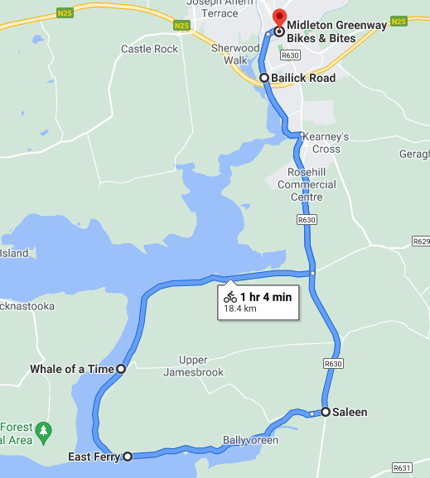

**Start & Finish Points:** Midleton Greenway Bikes & Bites

**Gradient:**

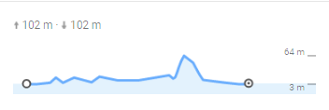

**Directions:**

* On the main street, take a left at JJ Coppingers onto Broderick Street
* Cycle the length of Bailick Road
* Turn right onto R360, signposted for Whitegate
* Travel for ­2kms, turn right at the crossroads signposted for East Ferry Church
* Follow the road to The Tavern at East Ferry pier
* Continue on the road keeping the water on your right until reaching Saleen village
* Turn left onto the R360 up the hill to return to Midleton
* **Alternatively re trace your route if you would like to see the estuary view from another angle (and avoid Saleen hill!)**
* Passing Ballinacurra, go through the traffic calming measures and pedestrian crossing, then take a left onto Bailick Road (L3621) to return to the town